HSE-MS DATA DASHBOARD, TRACKER & 3-YEAR TRENDING
Data-Capturing Charts, KPI Scorecard & Performance Trend — 2023 · 2024 · 2025

1. HSE-MS KPI Scorecard & Tracker (All-in-One)
Single-source tracker of SWDA's leading and lagging HSE indicators captured through the HSE-MS over the last three years. Green trend = improving against target.
HSE KPI (Metric) | 2023 | 2024 | 2025 | Trend | Target
Safe Man-Hours Worked | 186,000 | 242,000 | 298,000 | ▲ Improving | Growth
Lost-Time Injuries (LTI) | 1 | 0 | 0 | ▼ Improving | 0
LTIF (per 200k hrs) | 1.08 | 0.00 | 0.00 | ▼ Improving | 0
Total Recordable Cases (TRC) | 3 | 2 | 1 | ▼ Improving | 0
TRCF (per 200k hrs) | 3.23 | 1.65 | 0.67 | ▼ Improving | < 1.0
First-Aid Cases (FAC) | 6 | 4 | 3 | ▼ Improving | Reduce
Near-Miss Reports (leading) | 22 | 41 | 63 | ▲ Improving | Increase
Reportable Spills | 2 | 1 | 0 | ▼ Improving | 0
Toolbox Talks Held | 140 | 210 | 280 | ▲ Improving | Increase
HSE Audit Findings — Closed / Raised | 15 / 18 | 23 / 24 | 29 / 29 | ▲ 100% close | 100% close
HSE Training Hours | 640 | 980 | 1,420 | ▲ Improving | Increase
2. Data-Capturing Dashboard — Core Charts
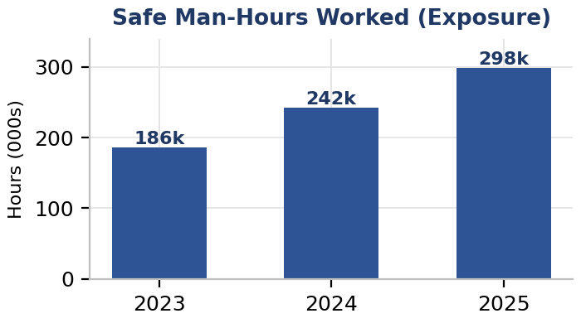 | 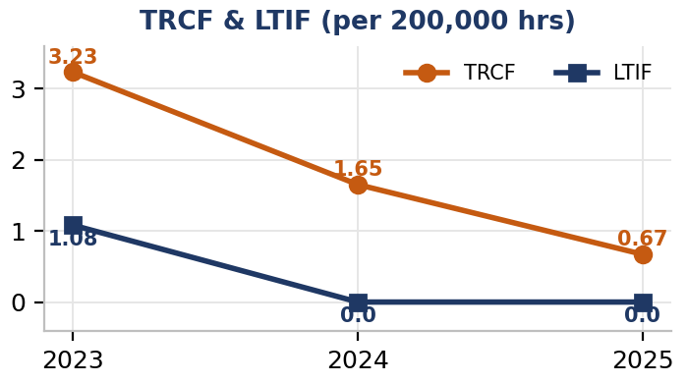
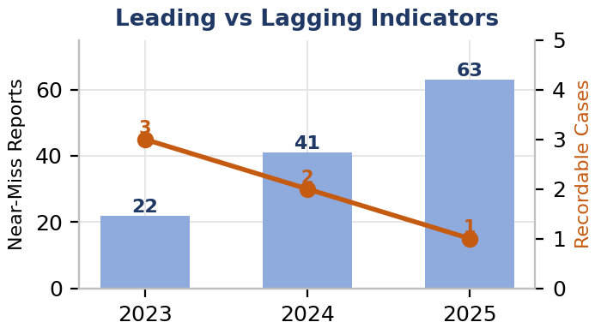 | 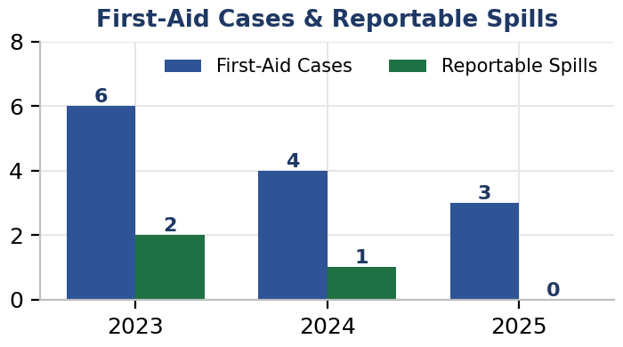
3. Assurance & Competency Trend Charts
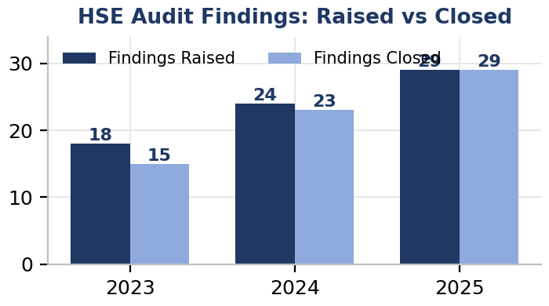 | 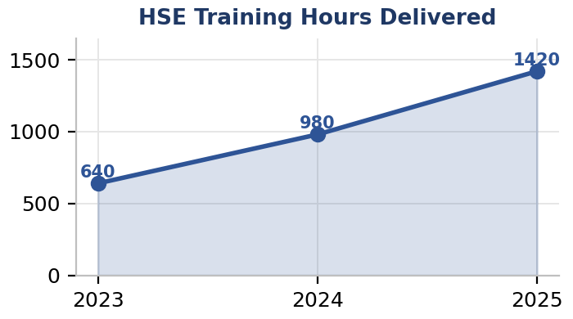
4. 3-Year Data Trending — Analysis
Exposure & lagging indicators: Safe man-hours grew ~60% (186k → 298k) while recordable cases fell from 3 to 1 and LTIs from 1 to zero — driving TRCF down from 3.23 to 0.67 (below the < 1.0 target) and LTIF to 0.00. Reportable spills reached zero in 2025.
Leading indicators: Near-miss reporting nearly tripled (22 → 63) and toolbox talks doubled (140 → 280) — a maturing reporting culture that correlates with the fall in actual harm. This inverse leading-to-lagging relationship is the clearest signal of a strengthening HSE-MS.
Assurance & competency: Audit-finding close-out improved to 100% (29/29) in 2025, and HSE training hours more than doubled (640 → 1,420), building the competency base evidenced in the Company Training Record Register.
5. Data Capture, Trending Method & Governance
Data is captured at source (incident reports, permits, toolbox-talk sheets, audit reports, timesheets), consolidated monthly into the HSE-MS tracker, and trended annually. Rates are normalised per 200,000 exposure hours for comparability. The dashboard is reviewed at Management Review and forms the basis of continual-improvement targets. Figures are maintained by the On-Site HSE Officer (Maxwell Wonuigwe) and Regulatory Compliance Manager (Sonia Somuvie).

ENDORSEMENT
Reviewed, approved and endorsed as SWDA's HSE-MS data dashboard & 3-year trend record:
____________________________________
Mr. Gliffeth Wonuigwe
Group CEO / Managing Director — South West Design Africa Limited (SWDA)
Date: 05 August 2026

